**EXPERIMENT – 8**

**Aim:** Demonstration of CI/CD pipeline with Source Code & Configuration Management using Jenkins & Git Plugin.

**Demo Task:**

For demo project, create CI/CD pipeline using Jenkins and demonstrating various commands and steps to perform source code and configuration management activities using CI/CD pipeline & Git Plugins.

**Task to be performed by Students:**

Create the CI/CD pipeline and follow below workflow for your project using Jenkins and Git Plugins.

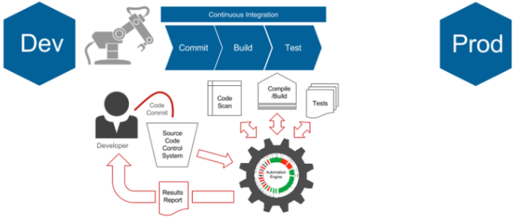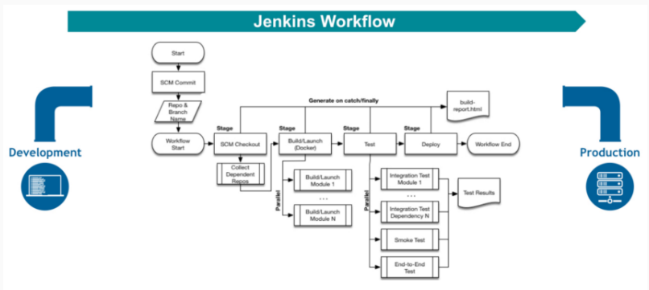

Make sure to add and get awareness for the following below tasks for your project/system assigned to you.

## Design and prepare pipeline as per workflow.

## Install essential plugins for Github organization.

## Run Single branch and multi branch pipelines.

## Add GitHub Organization Folder item type and adds "Github" as a branch source on Multi branch pipelines

Hints:

<http://www.mastertheboss.com/javaee/jenkins/jenkins-source-code-management-with-git>

<https://www.youtube.com/watch?v=h8gbk7coq5g>

<https://github.com/jenkinsci/git-plugin>

<https://www.jenkins.io/pipeline/getting-started-pipelines/>